MILANA ZARIĆ
Harp
CURRICULUM VITAE

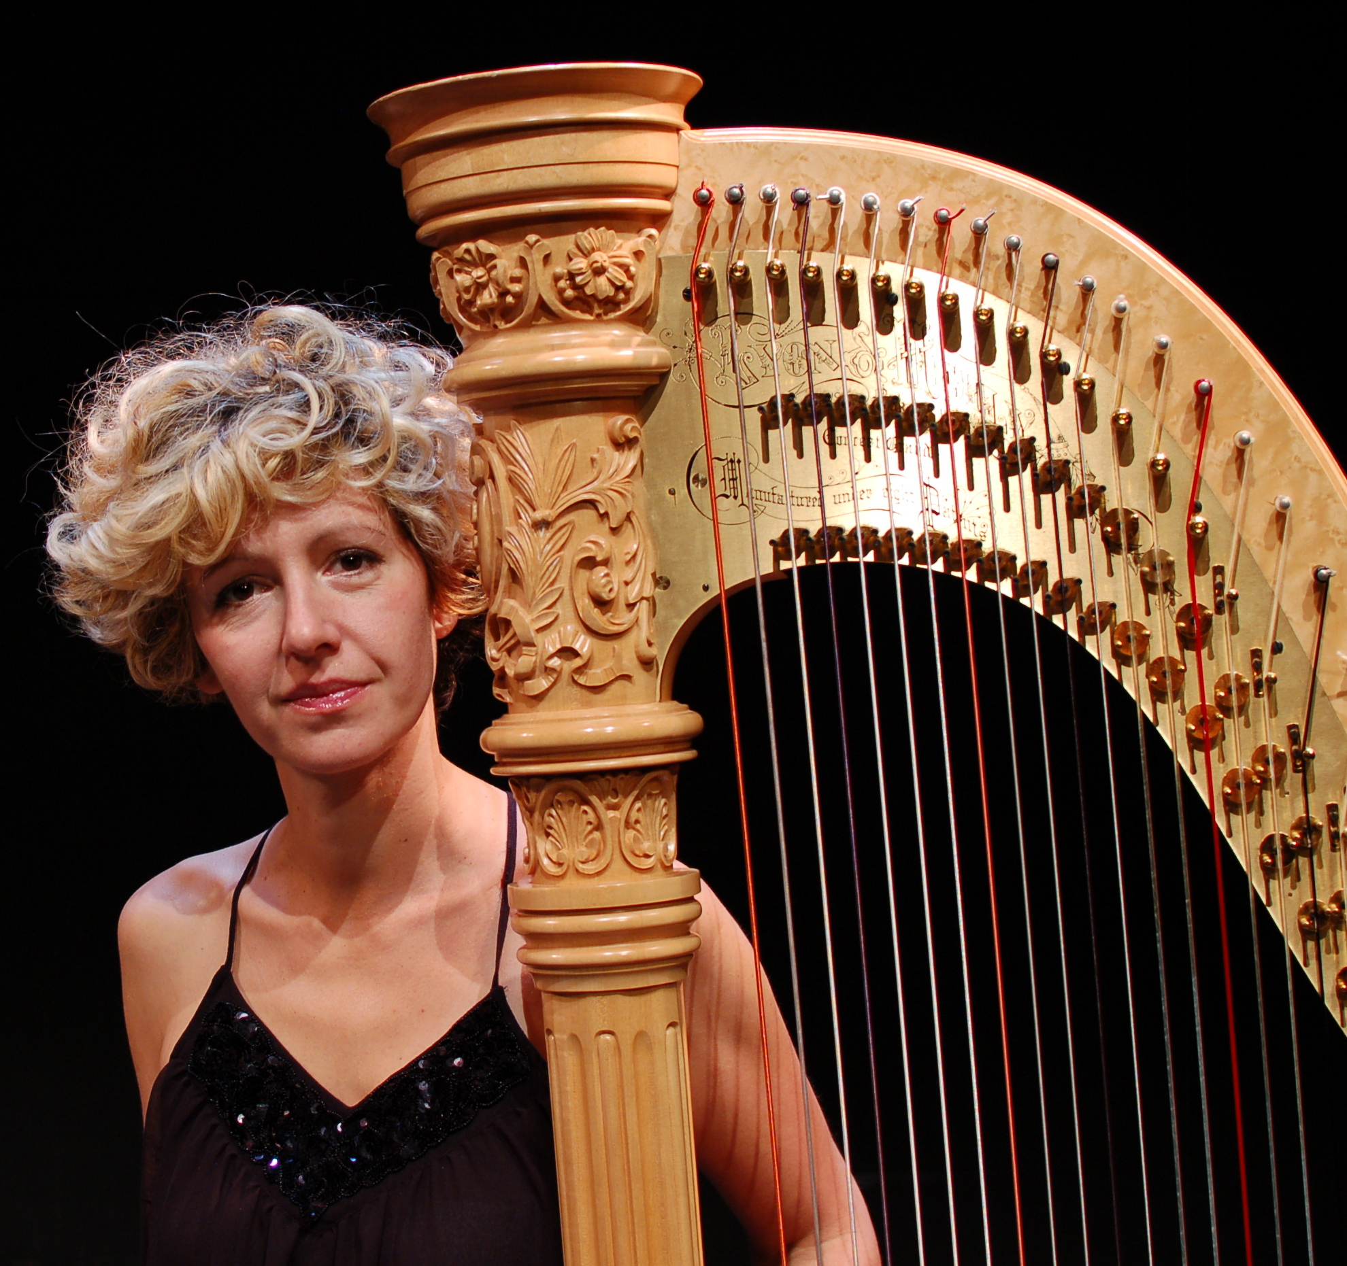

Date and place of birth:
21st August 1977, Belgrade, Yugoslavia

Contact details:
e mail: milana.zaric3@gmail.com
personal web site: www.milanazaric.com

Education:

Master Studies (2011)
Koninklijk Conservatorium, Den Haag
Main subject:
Contemporary harp music and improvisation, with Ernestine Stoop
Title of Master research:
‘Structuring free improvisation in an ensemble of plucked strings and percussion’

Postgraduate Advanced Diploma (2002)
Trinity College of Music, London, UK
Postgraduate Advanced Diploma in Harp Performance,
With Gabriella dall’Olio, Sioned Williams and Imogen Barford

Bachelor Studies (2000)
Faculty of Music, University of Arts, Belgrade
Classical Harp Performance, with Milica Barić

Professional experience:
Current position:
Principal Harp, Belgrade Philharmonic Orchestra, 2005- present
www.bgf.co.rs

Previous position:
Principal harpist, National Theatre and Opera of Novi Sad, Serbia, 2004-2005

Prizes and scholarships:
• Schuurman Schimmel – van Outeren Stichting,
for Master studies at Koncon, 2010-2011
• Hoeve Zadoks Fonds, for Master studies at Koncon, 2009-2010
• Royal Conservatoire Scholarship, Master studies, 2009-2011
• Kathryn Creed & Trinity College of Music Funds Award for Individual
Programme of Study, London, 2002-2003
• Trinity College of Music Funds Award for Postgraduate Advanced
Diploma, London, 2000-2002
• Accademia Musicale Chigiana Award, Siena, Italy, 1998
• Ministry of Culture of Republic of Serbia scholarship for development of scientific and artistic talents, Belgrade, Serbia, 1997-1998
• Zepter Foundation scholarship, 1996-1999
• First Prize at the International Harp Competition Petar Konjovic, Belgrade, 1996
• First Prize at the Republic of Serbia Harp Competition, 1996

Orchestra:
• Belgrade Philharmonic Orchestra
http://www.bgf.rs
• No Borders Orchestra, dir. Premil Petrović http://www.nobordersorchestra.org
• National Theatre and Opera of Novi Sad
• Radio Symphony Orchestra of Belgrade, dir. David Porcelijn
• Macedonian Philharmonic Orchestra
• Symphony orchestra of Vojvodina
• Madlenianum Chamber Opera orchestra, Belgrade
• National Opera House Orchestra, Belgrade
• Trinity College of Music Symphony Orchestra, dir. Diego Masson

Ensembles:
• Ensemble Studio6 (founder) www.studio6.st
• Žebeljan ensemble, dir.Isidora Žebeljan, Belgrade
• Atlas/Nieuw Ensemble, Amsterdam
• Trio Timbre, flute, viola and harp, Belgrade (founder)
• Ensemble Echoes, Den Haag (founder)
• Omnibus Ensemble, dir.A.Kim, Uzbekistan
• Modello Ensemble, dir.Ezequiel Menalled, Den Haag
• Sonology Electro Acoustic Ensemble, dir.Richard Barrett
• Conduction ensemble, dir.Butch Morris
• Ligeti Academy Ensemble, Amsterdam

Festivals:
• Richard Barrett@Spectrum festival, New York City
• Ring Ring Festival, Belgrade
• November music, Den Bosch, The Netherlands
• Culturescapes Balkans, Basel, Switzerland
• Operadagen Rotterdam, The Netherlands
• BEAM, London
• DoEK Festival, Musiekgebuw, Amsterdam
• International Review of Composers Festival, Belgrade
• BEMUS, Belgrade
• BITEF, Belgrade
• Music Biennale, Zagreb
• Showroom of contemporary sound festival, Zagreb
• International harp festival, Belgrade

Noteworthy performances (solo and chamber):

• tendril for harp and electronics by R.Barrett – performances in Belgrade, Singapore, Melbourne, London and New York, with Richard Barrett, 2014-2015
• Codex I, III, XII, XVI by R.Barrett –with Peter Evans, TILT Brass, Lester St.Louis - performances at Spectrum, New York City, June 2015
• Freude for two harps and voices, by K.Stockhausen - Serbian premiere in April 2015, with Gorana Ćurgus
• Maximum for flute, violin, viola and harp with orchestra, by B.Yusupov – with soloists from Zagreb, Ljubljana and Belgrade, with Belgrade Philharmonic Orchestra
• Concert season of Ensemble Studio6 – 11 concerts in 3 Serbian cities, 2014
• Chichester Psalms by Leonard Bernstein for choir, organ, harp and percussion, Opening of the Culturescapes Festival, Basel, October 2013
• Songs of wars I have seen by Heiner Goebbels, cond. Sian Edwards, BEMUS festival, Belgrade, October 2013.
• solo piece Living Room by Falk Huebner, at Operadagen festival, Rotterdam & November Music festival, Den Bosch, 2013
• Imagination mirroring the interpretation, around the music of J.S.Bach, solo project, International Harp Festival, Parobrod, Belgrade, April 2012
• Les resonances inconnues, solo project, NEW Festival, Theatre de Regentes, June 2011
Pieces by Falk Huebner, Hugo Morales, George Aperghis, Alberto Ginastera (self arrangement of a harp concerto), ensemble improvisation
• Contemporary music harp recital, International Review of Composers Festival, Belgrade, Serbia, November 2010
Serbian premieres by G.Aperghis, R.Murray Schafer and world premiere of new piece by Jasna Velicković, for percussion and amplified harp
• Solo harp recital, theatrical project, Royal Conservatoire, Den Haag, June 2010
Pieces by H.Birtwistle, R.Murray Schafer, Ton That Tiet and premiere of Harp in a box by Teodora Stepančić
• Nieuw/Atlas Ensemble, Amsterdam, August 2009
New written and improvised pieces for Atlas ensemble by Fabio Nieder, Stefano Pierini, Francisco Trigueras, Artjom Kim
• Omnibus Ensemble at Prince Claus Awards, Musiekgebouw aan’t IJ, Amsterdam, Dec 2009.
• Performance in Ljubica Maric - Centenary of birth Festival, Uilenburger Sinagoge, Amsterdam; City Hall, Belgrade, November 2009.
Pieces by Serbian composer Ljubica Maric and her Dutch circle of friends – Marius Flothuis, Bertus van Lier, Guillaume Landre
• Andre Caplet: La Conte fantastique,
for solo harp and chamber orchestra, City Hall, Belgrade, 2008.
• Frank Martin: Petite Symphonie Concertante,
For harp, piano, harpsichord and chamber orchestra, David Porcelijn, conductor; Kolarac Foundation Hall, Belgrade, 2008.

Improvised music:

• Electro acoustic improvisations @ ImprovE2 concerts, with Chris Cutler, Annie Gosfield, Paul Pignon, Biliana Voutchova, Svetlana Maraš, Manja Ristić, Nenad Marković, Vukašin Djelić, Duo Blank Disc…
2013-2015
• Ring Ring festival 2015, improvised music with Agusti Fernandez
• Improvised sets with Golden Fur Ensemble; with Dave Brown - Melbourne, Australia, July 2014
• Solo improvisation, Spring Festival, Koncon, cooperation with composer/improviser Yedo Gibson
• Echoes ensemble (harp, piano, koto, percussion) The Hague 2011
• Richard Barrett’s Sonology ensemble with Evan Parker (January 2011), Sarah Nicolls (March 2011)
• Doek Festival, Musiekgebouw Amsterdam, Peter van Bergen’s IOM project, Dec 2010.
• Butch Morris, Conduction, Koncon, Den Haag, Nov 2010.
• Atlas Academy, leader of an improvisation ensemble (harp, qanun, setar, kemence, percussion), Conservatoire of Amsterdam, August 2010

First performances:

solo/with electronics

• Richard Barrett tendril for harp and electronics, 2014
• Svetlana Maraš Codon 24 for electric harp and electronics, 2014
• Ana Gnjatovic: Sidenotes for solo harp, inspired by and performed together with Suite BWV 997 by J.S.Bach (2012)
• Hugo Morales Torque for harp and pedal operated DC motors (2011)
• Falk Huebner Living room, staged piece for harp, soundtrack and video (June 2011)
• Teodora Stepancic: Harp in a box for solo harp (2010)
group:

• Richard Barrett, Codex XII, Spectrum, NYC, June, 2015
• Richard Barrett: Codex XVI with Ensemble Studio6, 2013
• Branka Popović Lines and circles, commissioned by Ensemble Studio6, 2013
• Sonja Mutić Pulsar, commissioned by Trio Timbre, 2013
• Stevan Kovacs Tickmayer Out of the settled world for oboe and harp (new version 2013)
• Jasna Velickovic: Shadow study #6 for harp with coils, percussions and electronics (2010)
• Ivan Brkljačić Three little absurdities, commissioned by Trio Timbre, 2008

Other activities:

• Private teaching
• Electric harp
• Concert harp workshops for composition students
• Organiser at Collective for improvised music ImprovE2 www.i2.rs
• Arrangement of Alberto Ginastera Concerto for harp and orchestra, for harp, two pianos and percussion (2011)

